**Exercitiul 1**

**Code**

**Result**

**Exercitiul 2**

**Code**

**Result**

**Exercitiul 3**

**Code**

**Result**

**Exercitiul 4**

**Code**

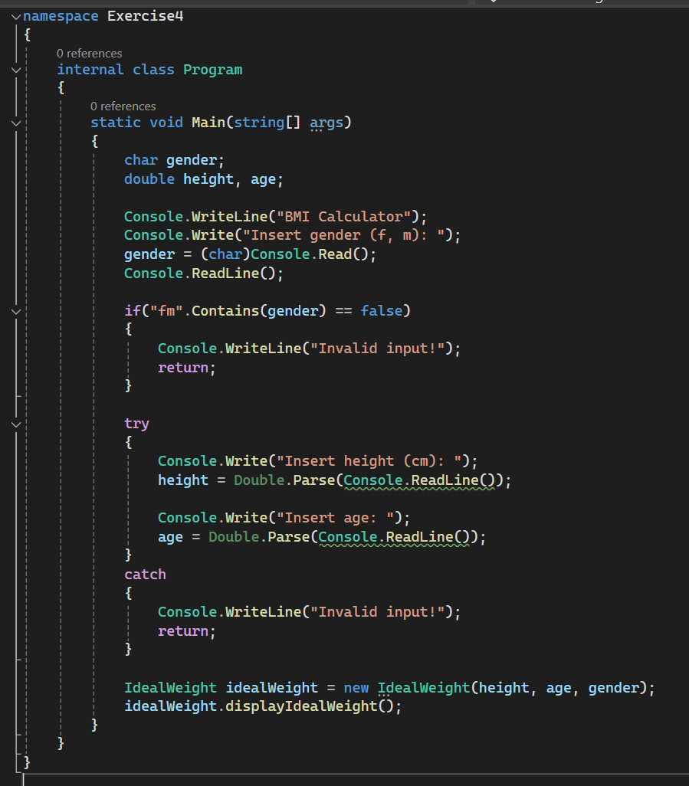

**Result**

**Exercitiul 5**

**Code**

**Result**

